

CS2201
-

APPLICATION

DEVELOPMENT

PRACTICES

(
Regulation

2023)

Project

Report

Name of the Student

:

Mohammed isa

Number

Register

:

22
AD
066

Year / Semester / Section

:

1
ST

Year

Branch

:

Artificial Intelligence and Data
Science

Project Title

:

GA
MESTOP

Department

of

Science

&

Humanities



2 | 2 | A | D | 0 | 6 | 6
Register No:

BONAFIDE CERTIFICATE

This is to certify that the work entitled
…….………...GAMESTOP………….. bonafide project done by
Mr./Ms.………………MOHAMMED ISA ………………………of semester
…….……….AIDS..………………… in the Application
Development Practices -CS2201 during the academic year 2022 - 2023

Staff – in – Charge Head of the Department

CHAPTER 1: Description of “GAMESTOP”

OBJECTIVES:
The objective of building this gaming product website using HTML, CSS and JAVASCRIPT is used to buy and sell product using internet, we can also buy and sell refurbished product.

INTRODUCTION:
“GAMESTOP” is basically a gaming PRODUCT webpage created by ISA from the Department of Artificial Intelligence and Data Science 1st Year. The stack used to create this webpage is HTML, CSS, and JAVASCRIPT. This webpage is built with a Home page, product page with cart and about us page.
And with a login page where the user can log in as well as signup too.

SOURCE CODE

CONTENTS

- HOME PAGE:
  - HTML WITH EXTERNAL CSS SHEET

- PRODUCT PAGE:
  - HTML WITH EXTERNAL CSS SHEET

- LOGIN PAGE o HTML o CSS o JAVASCRIPT

HOME PAGE:

HTML CODE:

<!DOCTYPE html>
<html lang="en">
<head>
<meta charset="UTF-8" />
<meta http-equiv="X-UA-Compatible" content="IE=edge" />
<meta name="viewport" content="width=device-width, initial-scale=1.0" />
<title>Website with Login & Registration Form</title>
<link rel="stylesheet" href="style.css" />

<link rel="stylesheet" href="https://unicons.iconscout.com/release/v4.0.0/css/line.css" />
</head>
<body>

<header class="header">
<nav class="nav">
<a href="#" class="nav_logo">GAMESTOP</a>

<ul class="nav_items">
<li class="nav_item">
<a href="#" class="nav_link">Home</a>
<a href="../login page/product page/product.html" class="nav_link">Product</a>
<a href="#" class="nav_link">Cart</a>
<a href="#" class="nav_link">Contact</a>
</li>
</ul>

<button class="button" id="form-open">Login</button>
</nav>
</header>

<section class="home">
<div class="form_container">
<i class="uil uil-times form_close"></i>
<
<div class="form login_form">
<form action="#">
<h2>Login|Signup</h2>

<div class="input_box">
<input type="email" placeholder="Enter your email" required />
<i class="uil uil-envelope-alt email"></i>
</div>
<div class="input_box">
<input type="password" placeholder="Enter your password" required />
<i class="uil uil-lock password"></i>
<i class="uil uil-eye-slash pw_hide"></i>
</div>

<div class="option_field">
<span class="checkbox">
<input type="checkbox" id="check" />
<label for="check">Remember me</label>
</span>
<a href="#" class="forgot_pw">Forgot password?</a>
</div>

<button class="button">Login Now</button>

<div class="login_signup">Don't have an account? <a href="#" id="signup">Signup</a></div>
</form>
</div>

<div class="form signup_form">
<form action="#">
<h2>Signup</h2>

<div class="input_box">
<input type="email" placeholder="Enter your email" required />
<i class="uil uil-envelope-alt email"></i>
</div>
<div class="input_box">
<input type="password" placeholder="Create password" required />
<i class="uil uil-lock password"></i>
<i class="uil uil-eye-slash pw_hide"></i>
</div>
<div class="input_box">
<input type="password" placeholder="Confirm password" required />
<i class="uil uil-lock password"></i>
<i class="uil uil-eye-slash pw_hide"></i>
</div>

<button class="button">Signup Now</button>

<div class="login_signup">Already have an account? <a href="#" id="login">Login</a></div>
</form>
</div>
</div>
</section>

<script src="script.js"></script>
</body>
</html>

EXTERNAL STYLE SHEET:

/* Import Google font - Poppins */
@import url("https://fonts.googleapis.com/css2?family=Poppins:wght@200;300;400;500;600;700&display=swap");
* {
margin: 0;
padding: 0;
box-sizing: border-box;
font-family: "Poppins", sans-serif;
}
a {
text-decoration: none;
}
.header {
position: fixed;
height: 80px;
width: 100%;
z-index: 100;
padding: 0 20px;
}
.nav {
max-width: 1100px;
width: 100%;
margin: 0 auto;
}
.nav,
.nav_item {
display: flex;
height: 100%;
align-items: center;
justify-content: space-between;
}
.nav_logo,
.nav_link,
.button {
color: #fff;
}
.nav_logo {
font-size: 25px;
}
.nav_item {
column-gap: 25px;
}
.nav_link:hover {
color: #d9d9d9;
}
.button {
padding: 6px 24px;
border: 2px solid #fff;
background: transparent;
border-radius: 6px;
cursor: pointer;
}
.button:active {
transform: scale(0.98);
}

/* Home */
.home {
position: relative;
height: 100vh;
width: 100%;
background-image: url("bg.jpg");
background-size: cover;
background-position: center;
}
.home::before {
content: "";
position: absolute;
height: 100%;
width: 100%;
background-color: rgba(0, 0, 0, 0.6);
z-index: 100;
opacity: 0;
pointer-events: none;
transition: all 0.5s ease-out;
}
.home.show::before {
opacity: 1;
pointer-events: auto;
}
/* From */
.form_container {
position: fixed;
max-width: 320px;
width: 100%;
top: 50%;
left: 50%;
transform: translate(-50%, -50%) scale(1.2);
z-index: 101;
background: #fff;
padding: 25px;
border-radius: 12px;
box-shadow: rgba(0, 0, 0, 0.1);
opacity: 0;
pointer-events: none;
transition: all 0.4s ease-out;
}
.home.show .form_container {
opacity: 1;
pointer-events: auto;
transform: translate(-50%, -50%) scale(1);
}
.signup_form {
display: none;
}
.form_container.active .signup_form {
display: block;
}
.form_container.active .login_form {
display: none;
}
.form_close {
position: absolute;
top: 10px;
right: 20px;
color: #0b0217;
font-size: 22px;
opacity: 0.7;
cursor: pointer;
}
.form_container h2 {
font-size: 22px;
color: #0b0217;
text-align: center;
}
.input_box {
position: relative;
margin-top: 30px;
width: 100%;
height: 40px;
}
.input_box input {
height: 100%;
width: 100%;
border: none;
outline: none;
padding: 0 30px;
color: #333;
transition: all 0.2s ease;
border-bottom: 1.5px solid #aaaaaa;
}
.input_box input:focus {
border-color: #7d2ae8;
}
.input_box i {
position: absolute;
top: 50%;
transform: translateY(-50%);
font-size: 20px;
color: #707070;
}
.input_box i.email,
.input_box i.password {
left: 0;
}
.input_box input:focus ~ i.email,
.input_box input:focus ~ i.password {
color: #7d2ae8;
}
.input_box i.pw_hide {
right: 0;
font-size: 18px;
cursor: pointer;
}
.option_field {
margin-top: 14px;
display: flex;
align-items: center;
justify-content: space-between;
}
.form_container a {
color: #7d2ae8;
font-size: 12px;
}
.form_container a:hover {
text-decoration: underline;
}
.checkbox {
display: flex;
column-gap: 8px;
white-space: nowrap;
}
.checkbox input {
accent-color: #7d2ae8;
}
.checkbox label {
font-size: 12px;
cursor: pointer;
user-select: none;
color: #0b0217;
}
.form_container .button {
background: #7d2ae8;
margin-top: 30px;
width: 100%;
padding: 10px 0;
border-radius: 10px;
}
.login_signup {
font-size: 12px;
text-align: center;
margin-top: 15px;
}

EXTERNAL JS CODE :

const formOpenBtn = document.querySelector("#form-open"),
home = document.querySelector(".home"),
formContainer = document.querySelector(".form_container"),
formCloseBtn = document.querySelector(".form_close"),
signupBtn = document.querySelector("#signup"),
loginBtn = document.querySelector("#login"),
pwShowHide = document.querySelectorAll(".pw_hide");

formOpenBtn.addEventListener("click", () => home.classList.add("show"));
formCloseBtn.addEventListener("click", () => home.classList.remove("show"));

pwShowHide.forEach((icon) => {
icon.addEventListener("click", () => {
let getPwInput = icon.parentElement.querySelector("input");
if (getPwInput.type === "password") {
getPwInput.type = "text";
icon.classList.replace("uil-eye-slash", "uil-eye");
} else {
getPwInput.type = "password";
icon.classList.replace("uil-eye", "uil-eye-slash");
}
});
});

signupBtn.addEventListener("click", (e) => {
e.preventDefault();
formContainer.classList.add("active");
});
loginBtn.addEventListener("click", (e) => {
e.preventDefault();
formContainer.classList.remove("active");
});

PRODUCT PAGE:

<!DOCTYPE html>
<html lang="en">
<head>
<meta charset="UTF-8">
<meta http-equiv="X-UA-Compatible" content="IE=edge">
<meta name="viewport" content="width=device-width, initial-scale=1.0">
<title>product page</title>
<link rel="stylesheet" href="css/all.min.css">
<link rel="stylesheet" href="css/style.css">
</head>
<body>
<div class="container">

<header class="header">
<nav class="nav">
<a href="#" class="nav_logo">GAMESTOP</a>

<ul class="nav_items">
<li class="nav_item">
<a href="#" class="nav_link">Home</a>
<a href="#" class="nav_link">Product</a>
<a href="#" class="nav_link">Cart</a>
<a href="#" class="nav_link">Contact</a>
</li>
</ul>

<button class="button" id="form-open">Login</button>
</nav>
</header>

<div class="products">

<div class="product">
<div class="image">
<img src="images/xbox.jpg" alt="">
</div>
<div class="namePrice">
<h3>Xbox Series X</h3>
<span>$ 600.99</span>
</div>
<p>The Xbox Series X/S are home video<br> game consoles developed by microsoft.</p>
<div class="stars">
<i class="fa-solid fa-star"></i>
<i class="fa-solid fa-star"></i>
<i class="fa-solid fa-star"></i>
<i class="fa-solid fa-star"></i>
<i class="fa-regular fa-star"></i>
</div>
<div class="bay">
<button> buy now </button>
</div>
</div>

<div class="product">
<div class="image">
<img src="images/rtx.png" alt="">
</div>
<div class="namePrice">
<h3>RTX 4080</h3>
<span>$ 1299.99</span>
</div>
<p>The NVIDIA® GeForce RTX™ 4090 is the ultimate GeForce GPU.</p>
<div class="stars">
<i class="fa-solid fa-star"></i>
<i class="fa-solid fa-star"></i>
<i class="fa-solid fa-star"></i>
<i class="fa-solid fa-star"></i>
<i class="fa-regular fa-star"></i>
</div>
<div class="bay">
<button> buy now </button>
</div>
</div>

<div class="product">
<div class="image">
<img src="images/controller.jpg" alt="">
</div>
<div class="namePrice">
<h3>controller.</h3>
<span>$ 100.99</span>
</div>
<p>controllers for pcs X-box and Playstations</p>
<div class="stars">
<i class="fa-solid fa-star"></i>
<i class="fa-solid fa-star"></i>
<i class="fa-solid fa-star"></i>
<i class="fa-solid fa-star"></i>
<i class="fa-solid fa-star"></i>
</div>
<div class="bay">
<button> buy now </button>
</div>
</div>

<div class="product">
<div class="image">
<img src="images/ps5.jpg" alt="">
</div>
<div class="namePrice">
<h3>Playstation</h3>
<span>$ 550.99</span>
</div>
<p>The high class graphics.</p>
<div class="stars">
<i class="fa-solid fa-star"></i>
<i class="fa-solid fa-star"></i>
<i class="fa-solid fa-star"></i>
<i class="fa-solid fa-star"></i>
<i class="fa-regular fa-star"></i>
</div><div class="bay">
<button> buy now </button>
</div>
</div>

<div class="product">
<div class="image">
<img src="images/pcs.png" alt="">
</div>
<div class="namePrice">
<h3>Pcs.</h3>
<span>$ 800.99</span>
</div>
<p>The high end portable computers.</p>
<div class="stars">
<i class="fa-solid fa-star"></i>
<i class="fa-solid fa-star"></i>
<i class="fa-solid fa-star"></i>
<i class="fa-solid fa-star"></i>
<i class="fa-regular fa-star"></i>
</div><div class="bay">
<button> buy now </button>
</div>
</div>

<div class="product">
<div class="image">
<img src="images/n.jpg" alt="">
</div>
<div class="namePrice">
<h3>Nitendo Switch</h3>
<span>$ 200.99</span>
</div>
<p>The latest nitendos available.</p>
<div class="stars">
<i class="fa-solid fa-star"></i>
<i class="fa-solid fa-star"></i>
<i class="fa-solid fa-star"></i>
<i class="fa-solid fa-star"></i>
<i class="fa-regular fa-star"></i>
</div><div class="bay">
<button> buy now </button>
</div>
</div>

</div>
</div>

<!-- Home -->
<section class="home">
<div class="form_container">
<i class="uil uil-times form_close"></i>
<!-- Login From -->
<div class="form login_form">
<form action="#">
<h2>Login</h2>

<div class="input_box">
<input type="email" placeholder="Enter your email" required />
<i class="uil uil-envelope-alt email"></i>
</div>
<div class="input_box">
<input type="password" placeholder="Enter your password" required />
<i class="uil uil-lock password"></i>
<i class="uil uil-eye-slash pw_hide"></i>
</div>

<div class="option_field">
<span class="checkbox">
<input type="checkbox" id="check" />
<label for="check">Remember me</label>
</span>
<a href="#" class="forgot_pw">Forgot password?</a>
</div>

<button class="button">Login Now</button>

<div class="login_signup">Don't have an account? <a href="#" id="signup">Signup</a></div>
</form>
</div>

<div class="form signup_form">
<form action="#">
<h2>Signup</h2>

<div class="input_box">
<input type="email" placeholder="Enter your email" required />
<i class="uil uil-envelope-alt email"></i>
</div>
<div class="input_box">
<input type="password" placeholder="Create password" required />
<i class="uil uil-lock password"></i>
<i class="uil uil-eye-slash pw_hide"></i>
</div>
<div class="input_box">
<input type="password" placeholder="Confirm password" required />
<i class="uil uil-lock password"></i>
<i class="uil uil-eye-slash pw_hide"></i>
</div>

<button class="button">Signup Now</button>

<div class="login_signup">Already have an account? <a href="#" id="login">Login</a></div>
</form>
</div>

<script src="script.js"></script>
</body>
</html>

EXTERNAL CSS :

@import url('https://fonts.googleapis.com/css2?family=Montserrat:wght@100;200;300;400;700;900&family=Raleway:wght@100;300;500;700&display=swap');

:root{
--bodyBack:black;
--textColor: #ffffff;
--starColor: #ffcd68;
--sectionBack: #756594;
}
*{
padding: 0;
margin: 0;
box-sizing: border-box;
font-family: 'Raleway', sans-serif;
}
body{
background-color: var(--bodyBack);
min-height: 100vh;
display: grid;
place-content: center;
}
.container{
width: 80vw;
height:80vh;
display: flex;
flex-direction: column;
justify-content: space-around;
}

a {
text-decoration: none;
}

.header {
position:sticky;
top: 0px;
height: 80px;
width: 100%;
padding: 0 auto;
}
.nav {
max-width: 1100px;
width: 100%;
margin: 0 auto;
}
.nav,
.nav_item {
display: flex;
height: 100%;
align-items: center;
justify-content: space-between;
}
.nav_logo,
.nav_link,
.button {
color: #fff;
}
.nav_logo {
font-size: 25px;
}
.nav_item {
column-gap: 25px;
}
.nav_link:hover {
color: #d9d9d9;
}
.button {
padding: 6px 24px;
border: 2px solid #fff;
background: transparent;
border-radius: 6px;
cursor: pointer;
}
.button:active {
transform: scale(0.98);
}

.products{
width: 100%;
align-self: center;
height: 70%;
display: flex;
justify-content: center;
flex-wrap: wrap;
gap: 40px;
}
.product{
position: relative;
background-color: var(--sectionBack);
width: 350px;
height: 100%;
box-shadow: 0 5px 20px rgba(0, 0, 0, .3);
display: flex;
flex-direction: column;
justify-content: space-between;
padding: 20px 20px 40px;
border-radius: 10px;
transition: .3s;
}
.product:hover{
transform: translateY(-15px);
box-shadow: 0 5px 10px rgba(0, 0, 0, .2);
}
.image{
width:100%;
height: 60%;
display: grid;
place-content: center;
}
.image img{
width: 240px;
}
.namePrice{
width: 100%;
display: flex;
justify-content: space-between;
}
.namePrice h3{
font-size: 2em;
text-transform: capitalize;
color: var(--textColor);
}
.namePrice span{
font-size: 1.5em;
color: var(--starColor);
}
.product p{
font-size: 18px;
line-height: 25px;
}
.stars svg{
font-size: 1.3em;
color: var(--starColor);
}
.bay{
position: absolute;
bottom: 20px;
right: 20px;
}
.bay button{
padding: 10px 20px;
border-radius: 7px;
border: none;
background-color: var(--textColor);
color: var(--sectionBack);
font-size: 18px;
text-transform: capitalize;
cursor: pointer;
transition: .5s;
}
.bay button:hover{
transform: scale(1.1);
}

.form_container {
position: fixed;
max-width: 320px;
width: 100%;
top: 50%;
left: 50%;
transform: translate(-50%, -50%) scale(1.2);
z-index: 101;
background: #fff;
padding: 25px;
border-radius: 12px;
box-shadow: rgba(0, 0, 0, 0.1);
opacity: 0;
pointer-events: none;
transition: all 0.4s ease-out;
}
.home.show .form_container {
opacity: 1;
pointer-events: auto;
transform: translate(-50%, -50%) scale(1);
}
.signup_form {
display: none;
}
.form_container.active .signup_form {
display: block;
}
.form_container.active .login_form {
display: none;
}
.form_close {
position: absolute;
top: 10px;
right: 20px;
color: #0b0217;
font-size: 22px;
opacity: 0.7;
cursor: pointer;
}
.form_container h2 {
font-size: 22px;
color: #0b0217;
text-align: center;
}
.input_box {
position: relative;
margin-top: 30px;
width: 100%;
height: 40px;
}
.input_box input {
height: 100%;
width: 100%;
border: none;
outline: none;
padding: 0 30px;
color: #333;
transition: all 0.2s ease;
border-bottom: 1.5px solid #aaaaaa;
}
.input_box input:focus {
border-color: #7d2ae8;
}
.input_box i {
position: absolute;
top: 50%;
transform: translateY(-50%);
font-size: 20px;
color: #707070;
}
.input_box i.email,
.input_box i.password {
left: 0;
}
.input_box input:focus ~ i.email,
.input_box input:focus ~ i.password {
color: #7d2ae8;
}
.input_box i.pw_hide {
right: 0;
font-size: 18px;
cursor: pointer;
}
.option_field {
margin-top: 14px;
display: flex;
align-items: center;
justify-content: space-between;
}
.form_container a {
color: #7d2ae8;
font-size: 12px;
}
.form_container a:hover {
text-decoration: underline;
}
.checkbox {
display: flex;
column-gap: 8px;
white-space: nowrap;
}
.checkbox input {
accent-color: #7d2ae8;
}
.checkbox label {
font-size: 12px;
cursor: pointer;
user-select: none;
color: #0b0217;
}
.form_container .button {
background: #7d2ae8;
margin-top: 30px;
width: 100%;
padding: 10px 0;
border-radius: 10px;
}
.login_signup {
font-size: 12px;
text-align: center;
margin-top: 15px;
}

OUTPUT :
HOME PAGE
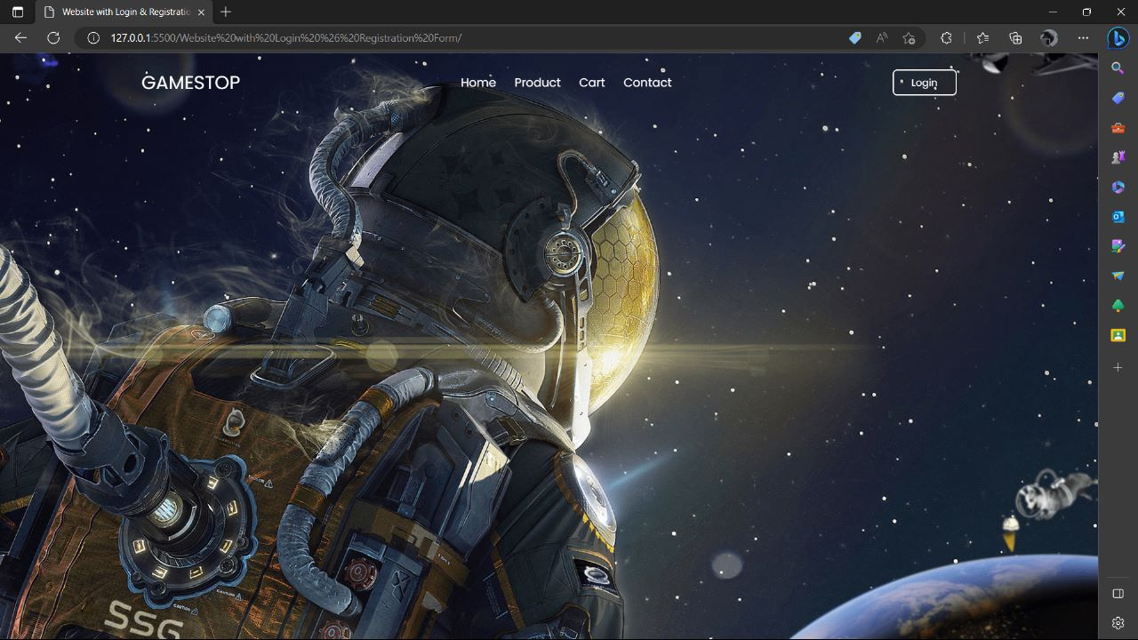

PRODUCT EXPLORE
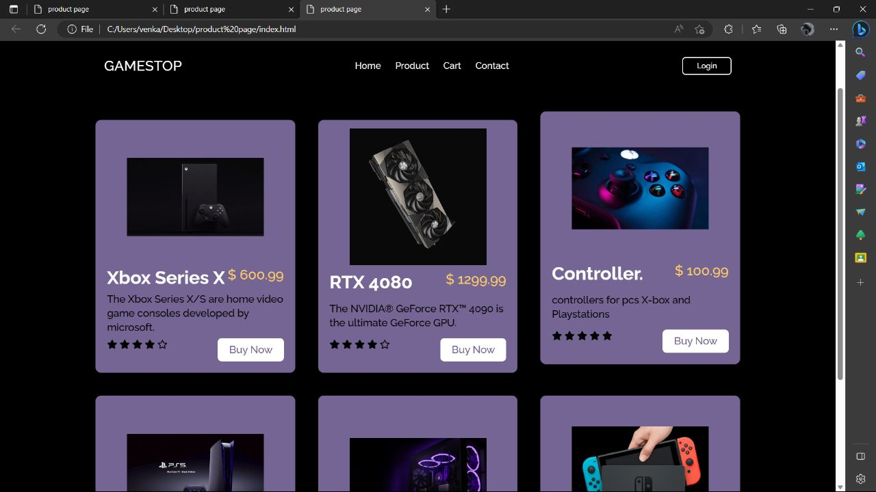

LOGIN PAGE
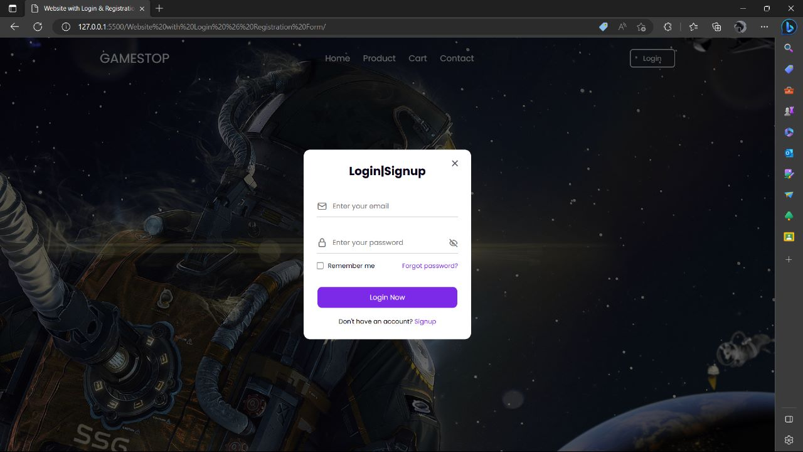
GITHUB PROJECT URL:

https://github.com/mohammedisa07/GAMESTOP

